*. Задача SD “Настроить postfix на нескольких серверах, чтобы можно было отправлять почту на локальные адреса” (https://forge.tcsbank.ru/case/5159594/info).
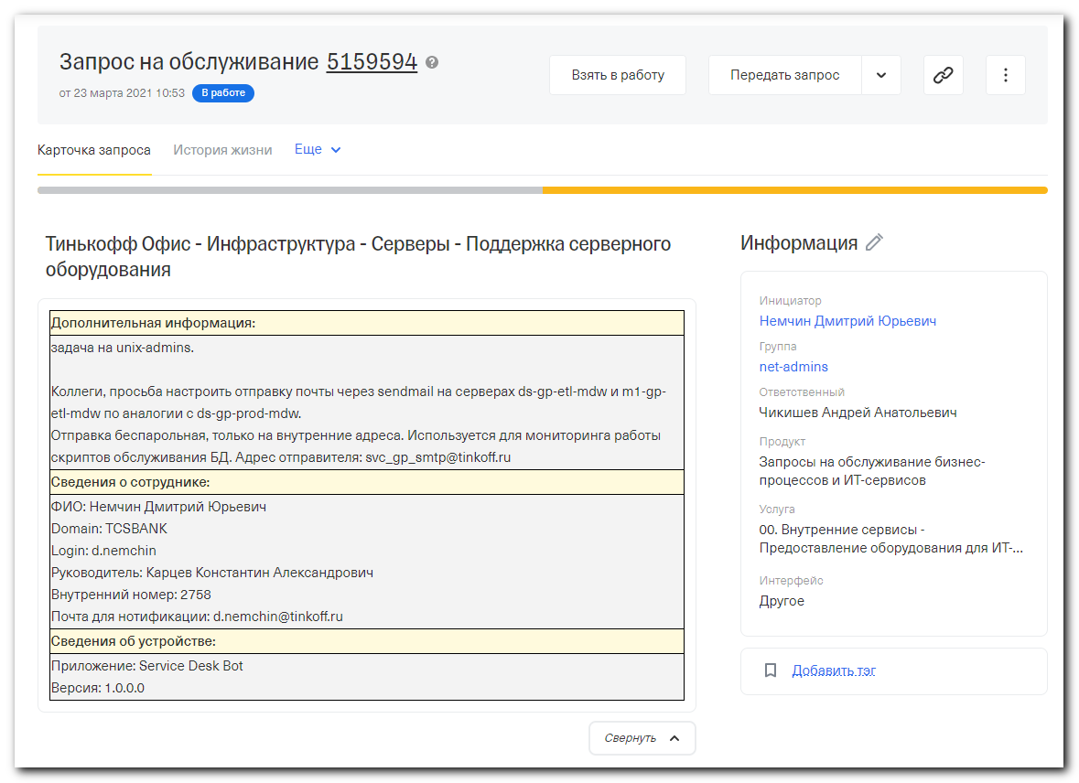

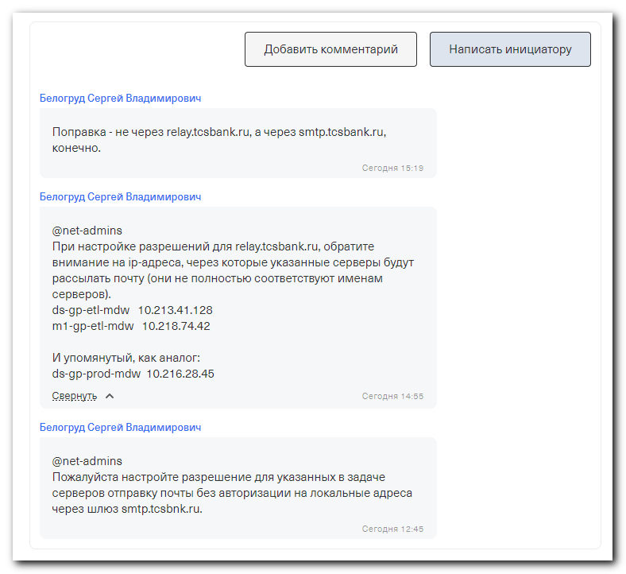

[root@ds-gp-etl-mdw ~]# systemctl stop postfix
[root@ds-gp-etl-mdw ~]# mkdir -p ~/work/20210324-1457/backup
[root@ds-gp-etl-mdw ~]# cp /etc/postfix/main.cf ~/work/20210324-1457/backup/
[root@ds-gp-etl-mdw ~]# vim /etc/postfix/main.cf
[root@ds-gp-etl-mdw ~]#

#
# Here is a file, that was taken from ds-gp-prod-mdw server.
# Something wrong with this configuration!
# Mail is not sending if I use it.
#
# I found probled. It’s require to install several packages and add two string in one text file and make .db from this file.
#
[root@ds-gp-etl-mdw ~]# cat /etc/postfix/main.cf
queue_directory = /var/spool/postfix
command_directory = /usr/sbin
daemon_directory = /usr/libexec/postfix
data_directory = /var/lib/postfix
mail_owner = postfix
myhostname = ds-gp-etl-mdw.tcsbank.ru
inet_interfaces = localhost
inet_protocols = ipv4
mydestination = $myhostname, localhost.$mydomain, localhost
unknown_local_recipient_reject_code = 550
relayhost = [smtp.tcsbank.ru]
alias_maps = hash:/etc/aliases
alias_database = hash:/etc/aliases
debug_peer_level = 10
debug_peer_list = 127.0.0.1
debugger_command =
PATH=/bin:/usr/bin:/usr/local/bin:/usr/X11R6/bin
ddd $daemon_directory/$process_name $process_id & sleep 5
sendmail_path = /usr/sbin/sendmail.postfix
newaliases_path = /usr/bin/newaliases.postfix
mailq_path = /usr/bin/mailq.postfix
setgid_group = postdrop
html_directory = no
manpage_directory = /usr/share/man
sample_directory = /usr/share/doc/postfix-2.10.1/samples
readme_directory = /usr/share/doc/postfix-2.10.1/README_FILES
smtp_sasl_auth_enable = yes
smtp_sasl_password_maps = hash:/etc/postfix/sasl_password
smtp_sasl_security_options =
smtp_sasl_mechanism_filter = login
smtpd_use_tls = no
smtp_generic_maps = hash:/etc/postfix/generic
smtp_sasl_tls_security_options = noanonymous

mailbox_size_limit = 512000000
[root@ds-gp-etl-mdw ~]#

#
# Here is how looks default file.
#
[root@ds-gp-etl-mdw ~]# egrep -v -e "^$" -e "^#" ~/work/20210324-1457/backup/main.cf
queue_directory = /var/spool/postfix
command_directory = /usr/sbin
daemon_directory = /usr/libexec/postfix
data_directory = /var/lib/postfix
mail_owner = postfix
inet_interfaces = localhost
inet_protocols = all
mydestination = $myhostname, localhost.$mydomain, localhost
unknown_local_recipient_reject_code = 550
alias_maps = hash:/etc/aliases
alias_database = hash:/etc/aliases

debug_peer_level = 2
debugger_command =
PATH=/bin:/usr/bin:/usr/local/bin:/usr/X11R6/bin
ddd $daemon_directory/$process_name $process_id & sleep 5
sendmail_path = /usr/sbin/sendmail.postfix
newaliases_path = /usr/bin/newaliases.postfix
mailq_path = /usr/bin/mailq.postfix
setgid_group = postdrop
html_directory = no
manpage_directory = /usr/share/man
sample_directory = /usr/share/doc/postfix-2.10.1/samples
readme_directory = /usr/share/doc/postfix-2.10.1/README_FILES
[root@ds-gp-etl-mdw ~]#

#
# I compare new and old files to find differencies in paths and name of server and so on.
# And I found two things.
# One is the server name.
# And another one is a string with path to file sasl_password.
#
[root@ds-gp-etl-mdw ~]# egrep -v -e "^$" -e "^#" ~/work/20210324-1457/backup/main.cf > ~/work/20210324-1457/main.cf.stripped
[root@ds-gp-etl-mdw ~]# vim -O /etc/postfix/main.cf ~/work/20210324-1457/main.cf.stripped
2 files to edit
[root@ds-gp-etl-mdw ~]#

#
# Here I created a special file, that was mentioned in main.cf file.
#
[root@ds-gp-etl-mdw ~]# ls /etc/postfix/sasl_password
ls: cannot access /etc/postfix/sasl_password: No such file or directory
[root@ds-gp-etl-mdw ~]# cat > /etc/postfix/sasl_password
smtp.tcsbank.ru svc_gp_smtp@tcsbank.ru:Boor9zeekood9chae8zi
[root@ds-gp-etl-mdw ~]# cat /etc/postfix/sasl_password
smtp.tcsbank.ru svc_gp_smtp@tcsbank.ru:Boor9zeekood9chae8zi
[root@ds-gp-etl-mdw ~]# ls -Alh /etc/postfix/sasl_password
-rw-r--r-- 1 root root 60 Mar 24 15:04 /etc/postfix/sasl_password
[root@ds-gp-etl-mdw ~]#

[root@ds-gp-etl-mdw ~]# chmod 600 /etc/postfix/sasl_password
[root@ds-gp-etl-mdw ~]# ls -Alh /etc/postfix/sasl_password
-rw------- 1 root root 60 Mar 24 15:04 /etc/postfix/sasl_password
[root@ds-gp-etl-mdw ~]#

[root@ds-gp-etl-mdw ~]# systemctl start postfix
[root@ds-gp-etl-mdw ~]# systemctl status postfix
● postfix.service - Postfix Mail Transport Agent
Loaded: loaded (/usr/lib/systemd/system/postfix.service; enabled; vendor preset: disabled)
Active: active (running) since Wed 2021-03-24 15:14:47 MSK; 2s ago
Process: 233400 ExecStop=/usr/sbin/postfix stop (code=exited, status=0/SUCCESS)
Process: 233486 ExecStart=/usr/sbin/postfix start (code=exited, status=0/SUCCESS)
Process: 233483 ExecStartPre=/usr/libexec/postfix/chroot-update (code=exited, status=0/SUCCESS)
Process: 233478 ExecStartPre=/usr/libexec/postfix/aliasesdb (code=exited, status=0/SUCCESS)
Main PID: 233559 (master)
Tasks: 3
Memory: 4.0M
CGroup: /system.slice/postfix.service
├─233559 /usr/libexec/postfix/master -w
├─233560 pickup -l -t unix -u
└─233561 qmgr -l -t unix -u

Mar 24 15:14:46 ds-gp-etl-mdw.tcsbank.ru systemd[1]: Starting Postfix Mail Transport Agent...
Mar 24 15:14:47 ds-gp-etl-mdw.tcsbank.ru postfix/postfix-script[233557]: starting the Postfix mail system
Mar 24 15:14:47 ds-gp-etl-mdw.tcsbank.ru postfix/master[233559]: daemon started -- version 2.10.1, configuration /etc/postfix
Mar 24 15:14:47 ds-gp-etl-mdw.tcsbank.ru systemd[1]: Started Postfix Mail Transport Agent.
[root@ds-gp-etl-mdw ~]#

[root@ds-gp-etl-mdw ~]# mailq
Mail queue is empty
[root@ds-gp-etl-mdw ~]#

[root@ds-gp-etl-mdw ~]# echo "This is testing email from host `hostname` on `date`" | mailx -s "`date +%Y%m%d-%H%M` Test mail" s.belogrud@tcsbank.ru
[root@ds-gp-etl-mdw ~]# telnet smtp.tcsbank.ru 25
Trying 10.219.80.12...
Connected to smtp.tcsbank.ru.
Escape character is '^]'.
220 ds-msk-mail1901.tcsbank.ru Microsoft ESMTP MAIL Service ready at Wed, 24 Mar 2021 15:17:53 +0300
^]

telnet> quit
Connection closed.
[root@ds-gp-etl-mdw ~]# mailq
-Queue ID- --Size-- ----Arrival Time---- -Sender/Recipient-------
F0F4B17A02CD 561 Wed Mar 24 15:16:32 root@ds-gp-etl-mdw.tcsbank.ru
(local data error while talking to smtp.tcsbank.ru[10.219.80.12])
s.belogrud@tcsbank.ru

-- 0 Kbytes in 1 Request.
[root@ds-gp-etl-mdw ~]#

#
# 20210325
# Mail not sendings.
#

[root@ds-gp-etl-mdw ~]# echo "This is testing email from host `hostname` on `date`" | mailx -s "`date +%Y%m%d-%H%M` Test mail" s.belogrud@tcsbank.ru
[root@ds-gp-etl-mdw ~]# mailq
-Queue ID- --Size-- ----Arrival Time---- -Sender/Recipient-------
15A1D17A02F4 561 Thu Mar 25 11:52:14 root@ds-gp-etl-mdw.tcsbank.ru
(unknown mail transport error)
s.belogrud@tcsbank.ru

18DEF17A02EE 8213 Wed Mar 24 23:32:40 svc_gp_smtp@tinkoff.ru
(unknown mail transport error)
dwh-dq@tcsbank.ru
greenplum_admins@tcsbank.ru
a.kozachek@tinkoff.ru
m.belousov@tinkoff.ru
v.tumanyan@tinkoff.ru

20B3917A02DB 90231 Wed Mar 24 17:43:54 gpadmin@ds-gp-etl-mdw.tcsbank.ru
(unknown mail transport error)
dwh-adm-db@tcsbank.ru

F0F4B17A02CD 561 Wed Mar 24 15:16:32 root@ds-gp-etl-mdw.tcsbank.ru
(unknown mail transport error)
s.belogrud@tcsbank.ru

-- 98 Kbytes in 4 Requests.
[root@ds-gp-etl-mdw ~]#

#
# I applyed default configuration, only add my four lines into it.
# And mail start sending!
#
[root@ds-gp-etl-mdw ~]# cat /etc/postfix/main.cf
queue_directory = /var/spool/postfix
command_directory = /usr/sbin
daemon_directory = /usr/libexec/postfix
data_directory = /var/lib/postfix
mail_owner = postfix
inet_interfaces = localhost
inet_protocols = all
mydestination = $myhostname, localhost.$mydomain, localhost
unknown_local_recipient_reject_code = 550
alias_maps = hash:/etc/aliases
alias_database = hash:/etc/aliases

debug_peer_level = 2
debugger_command =
PATH=/bin:/usr/bin:/usr/local/bin:/usr/X11R6/bin
ddd $daemon_directory/$process_name $process_id & sleep 5
sendmail_path = /usr/sbin/sendmail.postfix
newaliases_path = /usr/bin/newaliases.postfix
mailq_path = /usr/bin/mailq.postfix
setgid_group = postdrop
html_directory = no
manpage_directory = /usr/share/man
sample_directory = /usr/share/doc/postfix-2.10.1/samples
readme_directory = /usr/share/doc/postfix-2.10.1/README_FILES

myhostname = ds-gp-etl-mdw.tcsbank.ru
inet_protocols = ipv4
mydomain = tcsbank.ru
myorigin = $myhostname
relayhost = [smtp.tcsbank.ru]

[root@ds-gp-etl-mdw ~]#

[root@ds-gp-etl-mdw ~]# mailq
-Queue ID- --Size-- ----Arrival Time---- -Sender/Recipient-------
18DEF17A02EE 8213 Wed Mar 24 23:32:40 svc_gp_smtp@tinkoff.ru
(unknown mail transport error)
dwh-dq@tcsbank.ru
greenplum_admins@tcsbank.ru
a.kozachek@tinkoff.ru
m.belousov@tinkoff.ru
v.tumanyan@tinkoff.ru

20B3917A02DB 90231 Wed Mar 24 17:43:54 gpadmin@ds-gp-etl-mdw.tcsbank.ru
(unknown mail transport error)
dwh-adm-db@tcsbank.ru

F0F4B17A02CD 561 Wed Mar 24 15:16:32 root@ds-gp-etl-mdw.tcsbank.ru
(unknown mail transport error)
s.belogrud@tcsbank.ru

-- 98 Kbytes in 3 Requests.
[root@ds-gp-etl-mdw ~]# sendmail -q
[root@ds-gp-etl-mdw ~]# mailq
Mail queue is empty
[root@ds-gp-etl-mdw ~]#

#
# This is history from server ds-gp-prod-mdw
# And on this server - my test email - is sending.
#

12 postmap /etc/postfix/generic

postmap /etc/postfix/sasl_password

16 echo "This is testing email from host 'hostname' on 'date'" | mailx -s "'date +%Y%m%d-%H%M' Test mail" a.chernyh@tcsbank.ru
17 yum install mailx
18 echo "This is testing email from host 'hostname' on 'date'" | mailx -s "'date +%Y%m%d-%H%M' Test mail" a.chernyh@tcsbank.ru
19 echo "This is the message body" | swaks --to a.chernyh@tcsbank.ru --from "svc_gp_smtp@tcsbank.ru" --server smtp.tcsbank.ru --auth LOGIN --auth-user "svc_gp_smtp" --auth-password "Boor9zeekood9chae8zi"
20 yum install swaks
21 echo "This is the message body" | swaks --to a.chernyh@tcsbank.ru --from "svc_gp_smtp@tcsbank.ru" --server smtp.tcsbank.ru --auth LOGIN --auth-user "svc_gp_smtp" --auth-password "Boor9zeekood9chae8zi"

50 yum install cyrus-sasl-plain cyrus-sasl-scram cyrus-sasl-md5 cyrus-sasl-ntlm
51 yum install cyrus-sasl-plain

[root@ds-gp-etl-mdw ~]# ls -Alh /etc/postfix/
total 128K
-rw-r--r-- 1 root root 21K Nov 4 2010 access
-rw-r--r-- 1 root root 12K Jul 29 2019 canonical
-rw-r--r-- 1 root root 9.9K Jul 29 2019 generic
-rw-r--r-- 1 root root 22K Sep 3 2012 header_checks
-rw-r--r-- 1 root root 995 Mar 25 12:08 main.cf
-rw-r--r-- 1 root root 6.0K Jul 29 2019 master.cf
-rw-r--r-- 1 root root 6.7K Mar 27 2007 relocated
-rw------- 1 root root 61 Mar 24 15:12 sasl_password
-rw-r--r-- 1 root root 13K Nov 22 2009 transport
-rw-r--r-- 1 root root 13K Jul 29 2019 virtual
[root@ds-gp-etl-mdw ~]# postmap /etc/postfix/sasl_password
[root@ds-gp-etl-mdw ~]# ls -Alh /etc/postfix/
total 136K
-rw-r--r-- 1 root root 21K Nov 4 2010 access
-rw-r--r-- 1 root root 12K Jul 29 2019 canonical
-rw-r--r-- 1 root root 9.9K Jul 29 2019 generic
-rw-r--r-- 1 root root 22K Sep 3 2012 header_checks
-rw-r--r-- 1 root root 995 Mar 25 12:08 main.cf
-rw-r--r-- 1 root root 6.0K Jul 29 2019 master.cf
-rw-r--r-- 1 root root 6.7K Mar 27 2007 relocated
-rw------- 1 root root 61 Mar 24 15:12 sasl_password
-rw------- 1 root root 12K Mar 25 12:34 sasl_password.db
-rw-r--r-- 1 root root 13K Nov 22 2009 transport
-rw-r--r-- 1 root root 13K Jul 29 2019 virtual
[root@ds-gp-etl-mdw ~]#

[root@ds-gp-etl-mdw ~]# yum install cyrus-sasl-plain cyrus-sasl-scram cyrus-sasl-md5 cyrus-sasl-ntlm

[root@ds-gp-etl-mdw ~]# yum install swaks

#
# Almost useless command. In this case. It doesn’t work even after this postfix start send emails.
#
[root@ds-gp-etl-mdw ~]# echo "This is the message body" | swaks --to s.belogrud@tcsbank.ru --from "svc_gp_smtp@tcsbank.ru" --server smtp.tcsbank.ru --auth LOGIN --auth-user "svc_gp_smtp" --auth-password "Boor9zeekood9chae8zi"
=== Trying smtp.tcsbank.ru:25...
=== Connected to smtp.tcsbank.ru.
<- 220 ds-msk-mail1901.tcsbank.ru Microsoft ESMTP MAIL Service ready at Thu, 25 Mar 2021 14:36:05 +0300
-> EHLO ds-gp-etl-mdw.tcsbank.ru
<- 250-ds-msk-mail1901.tcsbank.ru Hello [10.219.79.98]
<- 250-SIZE 1073741824
<- 250-PIPELINING
<- 250-DSN
<- 250-ENHANCEDSTATUSCODES
<- 250-8BITMIME
<- 250-BINARYMIME
<- 250-CHUNKING
<- 250 SMTPUTF8
*** Host did not advertise authentication
-> QUIT
<- 221 2.0.0 Service closing transmission channel
=== Connection closed with remote host.
[root@ds-gp-etl-mdw ~]#

[root@ds-gp-etl-mdw ~]# journalctl -xe | less
...
Mar 25 14:43:25 ds-gp-etl-mdw.tcsbank.ru postfix/qmgr[253858]: 913AE17A02FA: from=<root@ds-gp-etl-mdw.tcsbank.ru>, size=561, nrcpt=1 (queue active)
Mar 25 14:43:25 ds-gp-etl-mdw.tcsbank.ru postfix/smtp[259371]: error: open database /etc/postfix/generic.db: No such file or directory
Mar 25 14:43:25 ds-gp-etl-mdw.tcsbank.ru postfix/smtp[259371]: warning: hash:/etc/postfix/generic is unavailable. open database /etc/postfix/generic.db: No
such file or directory
...

#
# These two rows I found on example server.
#
[14:48:33 root@ds-gp-prod-mdw ~]# egrep -v -e "^#" /etc/postfix/generic
root@ds-gp-prod-mdw.tcsbank.ru svc_gp_smtp@tcsbank.ru
gpadmin@ds-gp-prod-mdw.tcsbank.ru svc_gp_smtp@tcsbank.ru
[14:48:58 root@ds-gp-prod-mdw ~]#

[root@ds-gp-etl-mdw ~]# egrep -v -e "^#" /etc/postfix/generic
[root@ds-gp-etl-mdw ~]# vim /etc/postfix/generic
[root@ds-gp-etl-mdw ~]# head -n 3 /etc/postfix/generic
root@ds-gp-prod-mdw.tcsbank.ru svc_gp_smtp@tcsbank.ru
gpadmin@ds-gp-prod-mdw.tcsbank.ru svc_gp_smtp@tcsbank.ru

[root@ds-gp-etl-mdw ~]# postmap /etc/postfix/generic
[root@ds-gp-etl-mdw ~]# systemctl stop postfix
[root@ds-gp-etl-mdw ~]# systemctl start postfix
[root@ds-gp-etl-mdw ~]#

[root@ds-gp-etl-mdw ~]# mailq
Mail queue is empty
[root@ds-gp-etl-mdw ~]#

#
# It was sent from m1-gp-etl-mdw.
#

Received: from m1-msk-mail1311.tcsbank.ru (10.216.58.121) by
ds-msk-mail1312.tcsbank.ru (10.216.60.122) with Microsoft SMTP Server (TLS)
id 15.0.1497.2 via Mailbox Transport; Thu, 25 Mar 2021 15:08:47 +0300
Received: from ds-msk-mail1902.tcsbank.ru (10.216.60.192) by
m1-msk-mail1311.tcsbank.ru (10.216.58.121) with Microsoft SMTP Server (TLS)
id 15.0.1497.2; Thu, 25 Mar 2021 15:08:47 +0300
Received: from m1-gp-etl-mdw.tcsbank.ru (10.219.78.66) by
ds-msk-mail1902.tcsbank.ru (10.216.60.192) with Microsoft SMTP Server id
15.2.792.3 via Frontend Transport; Thu, 25 Mar 2021 15:08:47 +0300
Received: by m1-gp-etl-mdw.tcsbank.ru (Postfix, from userid 0)
id 71B23740581; Thu, 25 Mar 2021 15:08:47 +0300 (MSK)
Date: Thu, 25 Mar 2021 15:08:47 +0300
To: <s.belogrud@tcsbank.ru>
Subject: 20210325-1508 Test mail
User-Agent: Heirloom mailx 12.5 7/5/10
MIME-Version: 1.0
Content-Type: text/plain; charset="us-ascii"
Content-Transfer-Encoding: 7bit
Message-ID: <20210325120847.71B23740581@m1-gp-etl-mdw.tcsbank.ru>
From: root <root@m1-gp-etl-mdw.tcsbank.ru>
Return-Path: root@m1-gp-etl-mdw.tcsbank.ru
X-MS-Exchange-Organization-Network-Message-Id: fcec021c-5118-4ed4-02ca-08d8ef86be90
X-MS-Exchange-Organization-AuthSource: ds-msk-mail1902.tcsbank.ru
X-MS-Exchange-Organization-AuthAs: Anonymous

This is testing email from host m1-gp-etl-mdw.tcsbank.ru on Thu Mar 25 15:08:47 MSK 2021

#
# If it forwarded.
#

-----Original Message-----
From: root <root@m1-gp-etl-mdw.tcsbank.ru>
Sent: Thursday, March 25, 2021 3:09 PM
To: Belogrud Sergey <s.belogrud@tinkoff.ru>
Subject: 20210325-1508 Test mail

This is testing email from host m1-gp-etl-mdw.tcsbank.ru on Thu Mar 25 15:08:47 MSK 2021

#
# This message looks differ.
# It was sent from ds-gp-prod-mdw
#

Received: from m1-msk-mail1311.tcsbank.ru (10.216.58.121) by
ds-msk-mail1312.tcsbank.ru (10.216.60.122) with Microsoft SMTP Server (TLS)
id 15.0.1497.2 via Mailbox Transport; Thu, 25 Mar 2021 12:24:08 +0300
Received: from m1-msk-mail1309.tcsbank.ru (10.216.58.139) by
m1-msk-mail1311.tcsbank.ru (10.216.58.121) with Microsoft SMTP Server (TLS)
id 15.0.1497.2; Thu, 25 Mar 2021 12:24:08 +0300
Received: from ds-gp-prod-mdw.tcsbank.ru (10.219.78.97) by
m1-msk-mail1309.tcsbank.ru (10.216.58.139) with Microsoft SMTP Server (TLS)
id 15.0.1497.2; Thu, 25 Mar 2021 12:24:07 +0300
Received: by ds-gp-prod-mdw.tcsbank.ru (Postfix, from userid 0)
id D4256340062; Thu, 25 Mar 2021 12:24:07 +0300 (MSK)
Date: Thu, 25 Mar 2021 12:24:07 +0300
To: <s.belogrud@tcsbank.ru>
Subject: 20210325-1224 Test mail
User-Agent: Heirloom mailx 12.5 7/5/10
MIME-Version: 1.0
Content-Type: text/plain; charset="us-ascii"
Content-Transfer-Encoding: 7bit
Message-ID: <20210325092407.D4256340062@ds-gp-prod-mdw.tcsbank.ru>
From: root <svc_gp_smtp@tcsbank.ru>
Return-Path: svc_gp_smtp@tcsbank.ru
X-MS-Exchange-Organization-AuthSource: m1-msk-mail1309.tcsbank.ru
X-MS-Exchange-Organization-AuthAs: Internal
X-MS-Exchange-Organization-AuthMechanism: 00
X-Originating-IP: [10.219.78.97]
X-ClientProxiedBy: ds-msk-mail1901.tcsbank.ru (10.216.60.191) To
m1-msk-mail1309.tcsbank.ru (10.216.58.139)
X-MS-Exchange-Organization-Network-Message-Id: 776b39bf-71bc-4899-a27b-08d8ef6fbdf0

#
# And if it was forwarded.
#

-----Original Message-----
From: svc_gp_smtp <svc_gp_smtp@tinkoff.ru>
Sent: Thursday, March 25, 2021 12:24 PM
To: Belogrud Sergey <s.belogrud@tinkoff.ru>
Subject: 20210325-1224 Test mail

This is testing email from host ds-gp-prod-mdw on Thu Mar 25 12:24:07 MSK 2021

#
# I used wrong server name!
# Each server has its differ name and I have change strings that were taken from example server.
#

[root@ds-gp-etl-mdw ~]# systemctl stop postfix
[root@ds-gp-etl-mdw ~]# ls -Alh /etc/postfix/
total 144K
-rw-r--r-- 1 root root 21K Nov 4 2010 access
-rw-r--r-- 1 root root 12K Jul 29 2019 canonical
-rw-r--r-- 1 root root 10K Mar 25 14:54 generic
-rw-r--r-- 1 root root 12K Mar 25 14:54 generic.db
-rw-r--r-- 1 root root 22K Sep 3 2012 header_checks
-rw-r--r-- 1 root root 1.3K Mar 25 14:31 main.cf
-rw-r--r-- 1 root root 6.0K Jul 29 2019 master.cf
-rw-r--r-- 1 root root 6.7K Mar 27 2007 relocated
-rw------- 1 root root 61 Mar 24 15:12 sasl_password
-rw------- 1 root root 12K Mar 25 12:34 sasl_password.db
-rw-r--r-- 1 root root 13K Nov 22 2009 transport
-rw-r--r-- 1 root root 13K Jul 29 2019 virtual
[root@ds-gp-etl-mdw ~]# rm /etc/postfix/generic.db
rm: remove regular file ‘/etc/postfix/generic.db’? y
[root@ds-gp-etl-mdw ~]# vim /etc/postfix/generic
[root@ds-gp-etl-mdw ~]# postmap /etc/postfix/generic
[root@ds-gp-etl-mdw ~]# head -n 3 /etc/postfix/generic
root@ds-gp-etl-mdw.tcsbank.ru svc_gp_smtp@tcsbank.ru
gpadmin@ds-gp-etl-mdw.tcsbank.ru svc_gp_smtp@tcsbank.ru

[root@ds-gp-etl-mdw ~]# ls -Alh /etc/postfix/
total 144K
-rw-r--r-- 1 root root 21K Nov 4 2010 access
-rw-r--r-- 1 root root 12K Jul 29 2019 canonical
-rw-r--r-- 1 root root 10K Mar 25 15:28 generic
-rw-r--r-- 1 root root 12K Mar 25 15:28 generic.db
-rw-r--r-- 1 root root 22K Sep 3 2012 header_checks
-rw-r--r-- 1 root root 1.3K Mar 25 14:31 main.cf
-rw-r--r-- 1 root root 6.0K Jul 29 2019 master.cf
-rw-r--r-- 1 root root 6.7K Mar 27 2007 relocated
-rw------- 1 root root 61 Mar 24 15:12 sasl_password
-rw------- 1 root root 12K Mar 25 12:34 sasl_password.db
-rw-r--r-- 1 root root 13K Nov 22 2009 transport
-rw-r--r-- 1 root root 13K Jul 29 2019 virtual
[root@ds-gp-etl-mdw ~]#

[root@ds-gp-etl-mdw ~]# systemctl start postfix
[root@ds-gp-etl-mdw ~]# echo "This is testing email from host `hostname` on `date`" | mailx -s "`date +%Y%m%d-%H%M` Test mail" s.belogrud@tcsbank.ru
[root@ds-gp-etl-mdw ~]# mailq
Mail queue is empty
[root@ds-gp-etl-mdw ~]#

Received: from ds-msk-mail1312.tcsbank.ru (10.216.60.122) by
ds-msk-mail1312.tcsbank.ru (10.216.60.122) with Microsoft SMTP Server (TLS)
id 15.0.1497.2 via Mailbox Transport; Thu, 25 Mar 2021 15:29:46 +0300
Received: from m1-msk-mail1901.tcsbank.ru (10.216.58.191) by
ds-msk-mail1312.tcsbank.ru (10.216.60.122) with Microsoft SMTP Server (TLS)
id 15.0.1497.2; Thu, 25 Mar 2021 15:29:46 +0300
Received: from ds-gp-etl-mdw.tcsbank.ru (10.219.78.106) by
m1-msk-mail1901.tcsbank.ru (10.216.58.191) with Microsoft SMTP Server id
15.2.792.3 via Frontend Transport; Thu, 25 Mar 2021 15:29:46 +0300
Received: by ds-gp-etl-mdw.tcsbank.ru (Postfix, from userid 0)
id 98EE417A058B; Thu, 25 Mar 2021 15:29:46 +0300 (MSK)
Date: Thu, 25 Mar 2021 15:29:46 +0300
To: <s.belogrud@tcsbank.ru>
Subject: 20210325-1529 Test mail
User-Agent: Heirloom mailx 12.5 7/5/10
MIME-Version: 1.0
Content-Type: text/plain; charset="us-ascii"
Content-Transfer-Encoding: 7bit
Message-ID: <20210325122946.98EE417A058B@ds-gp-etl-mdw.tcsbank.ru>
From: root <svc_gp_smtp@tcsbank.ru>
Return-Path: svc_gp_smtp@tcsbank.ru
X-MS-Exchange-Organization-Network-Message-Id: da866be6-8cfd-4aea-aab7-08d8ef89ad18
X-MS-Exchange-Organization-AuthSource: m1-msk-mail1901.tcsbank.ru
X-MS-Exchange-Organization-AuthAs: Anonymous

#
# And forwarded message.
#

-----Original Message-----
From: root <svc_gp_smtp@tcsbank.ru>
Sent: Thursday, March 25, 2021 3:30 PM
To: Belogrud Sergey <s.belogrud@tinkoff.ru>
Subject: 20210325-1529 Test mail

This is testing email from host ds-gp-etl-mdw.tcsbank.ru on Thu Mar 25 15:29:46 MSK 2021

